**FLIGHT FARE PREDICTION SYSTEM**

|  |
| --- |
| ***A Project Report Submitted*** |
| ***In Partial Fulfillment*** |
| ***for award of Bachelor of Technology*** |
|  |
| **in** |
| **B.Tech (CS)** |
|  |
| **by** |
|  |
| **Rahul Kumar Giri (2201330120093)**  **Priyansh Kisan (2201330120088)**  **Ayush Tayal (2201330120036)** |
|  |
|  |
| **Under the Supervision of**  **Prof. Dr. Deepak Uprety**  **Professor,Computer Science** |
| Home  **COMPUTER SCIENCE**  **SCHOOL OF COMPUTER SCIENCE AND EMERGING TECHNOLOGIES**  **NOIDA INSTITUTE OF ENGINEERING AND TECHNOLOGY, GREATER NOIDA**  **(An Autonomous Institute)**  **Affiliated to**  **DR. A.P.J. ABDUL KALAM TECHNICAL UNIVERSITY, LUCKNOW**  **May,2024** |
|  |

**DECLARATION**

We hereby declare that the work presented in this report entitled “**FLIGHT FARE PREDICTION SYSTEM**”, was carried out by us. We have not submitted the matter embodied in this report for the award of any other degree or diploma of any other University or Institute. We have given due credit to the original authors/sources for all the words, ideas, diagrams, graphics, computer programs, experiments, results, that are not my original contribution. We have used quotation marks to identify verbatim sentences and given credit to the original authors/sources.

We affirm that no portion of our work is plagiarized, and the experiments and results reported in the report are not manipulated. In the event of a complaint of plagiarism and the manipulation of the experiments and results, we shall be fully responsible and answerable.

|  |  |
| --- | --- |
| Name : Rahul Kumar Giri  Roll Number : 2201330120093  Name : Priyansh Kisan  Roll Number : 2201330120088  Name : Ayush Tayal  Roll Number : 2201330120036 |  |

**CERTIFICATE**

Certified that **Rahul Kumar Giri ,** **Priyansh Kisan and Ayush Tayal**  (enrolment numbers: 2201330120088) have carried out the research work presented in this Project Report entitled “**Flight Fare Prediction System”** for the award of **Bachelor of Technology**, **Computer Science** from Dr. APJ Abdul Kalam Technical University, Lucknowunder our supervision. The Project Report embodies results of original work, and studies are carried out by the students herself/himself. The contents of the Project Report do not form the basis for the award of any other degree to the candidate or to anybody else from this or any other University/Institution.

|  |
| --- |
| Signature  Dr. Deepak Uprety  Professor  Computer Science  NIET Greater Noida  Date: 11/05/2024 |
|  |  |

**ACKNOWLEDGEMENT**

We would like to express my gratitude towards Guide name and Co guide name for their guidance and constant supervision as well as for providing necessary information regarding the project & also for their support in completing the project.

Our thanks and appreciations to respected HOD for their motivation and support throughout.

# ABSTRACT

The Flight Fare Prediction System offers a comprehensive solution to the challenge of accurately forecasting flight ticket prices amidst the dynamic landscape of the airline industry. With the industry's continuous expansion and evolving fare structures, predicting flight fares has become increasingly complex. This system harnesses the power of machine learning algorithms and extensive historical flight data to deliver precise fare predictions. Drawing from a vast dataset encompassing various factors such as travel dates, destinations, airlines, departure times, and other pertinent variables, the system employs advanced machine learning techniques to discern patterns and relationships, thereby enabling reliable predictions of future flight fares. Utilizing a blend of regression algorithms and ensemble methods, the Flight Fare Prediction System ensures high accuracy in its predictions. It takes into account a multitude of factors influencing ticket prices, including seasonality, market demand, fuel costs, competition, and other dynamic variables. By integrating real-time data updates, the system ensures that predictions remain current and reflective of the latest market trends.

**TABLE OF CONTENTS**

Declaration

Certificate

Acknowledgements Abstract

List of Abbreviations

**CHAPTER 1: INTRODUCTION**

**CHAPTER 2: LITERATURE REVIEW**

**CHAPTER 3: REQUIREMENTS AND ANALYSIS**

**CHAPTER 4: PROPOSED METHODOLOGY**

**CHAPTER 5: RESULTS**

**CHAPTER 6: CONCLUSION AND FUTURE WORK**

(Signature of the Candidate)

Name: ……………………..

Enrollment No:…………….

(Signature of the Candidate)

Name: ……………………..

Enrollment No:…………….

(Signature of the Candidate)

Name: ……………………..

Enrollment No:…………….

(Signature of the Candidate)

Name: ……………………..

Enrollment No:…………….

**CHAPTER 1**

**INTRODUCTION**

**DOMAIN INTRODUCTION**

Machine learning is an area of artificial intelligence (AI) that focuses oncreating statistical models and algorithms that let computers learn from data without beingexplicitly explained and make predictions. It contains a variety of methods and methodsthat let computers spot trends, understand situations better, and get better over time.Many industries, including finance, healthcare, marketing, transportation, andtechnology, among others, now depend heavily on machine learning. It has the ability toalter how companies and organizations run their operations as well as how we usetechnology in our daily lives.

There are many different types of machine learning, such as supervised, semi-supervised, unsupervised, and reinforcement learning. Under supervision, an algorithm is trained on correctly extracted, labelled data and then learns predictions based on tagged cases. In contrast, unsupervised learning involves training an algorithm on unlabeled data, with the goal of the program being to find patterns or links in the unlabeled data.  
Machine learning is widely applied to a variety of tasks, such as recommendation systems, natural language processing, fraud detection, anomaly detection, predictive analytics, and photo and speech recognition. To do this, data must be gathered and prepared, models must be developed and tested, and models must be successful.

However, there are moral questions raised by machine learning regarding data in algorithms, privacy, and the impact on society and industry. It is essential to apply machine learning responsibly and ethically in order to guarantee that the benefits of this technology are realized while minimizing potential risks.   
To sum up, machine learning is a rapidly developing field that is changing business and the course of technology. This allows computers to learn from data and make predictions or decisions, which could change the way people interact with technology in many areas of our lives.

**PROJECT INTRODUCTION**

The Flight Fare Prediction System represents a machine learning initiative dedicated to estimating aircraft ticket costs using relevant features and historical data. This approach serves travellers, travel firms, and airlines, aiding them in projecting trip expenses for planning, budgeting, and making informed choices.

The project's objective lies in constructing a dependable machine-learning model for forecasting flight expenses by encompassing various factors such as travel class, airline, departure and arrival destinations, travel dates, and other relevant details. To train the algorithm effectively, an extensive dataset comprising historical flight data, including ticket pricing and related attributes, will be utilized.

Users of the Flight Fare Prediction System will gain access to a user-friendly interface where they can input their travel information and receive an estimated flight fare. The system will meticulously analyse input data and generate precise predictions through feature engineering, data preprocessing, and machine learning methodologies. Rigorous evaluation criteria will be applied to ensure the accuracy and reliability of the model and its associated attributes.

While the accuracy of predictions heavily relies on the quality of the training and prediction data, the project places a premium on data quality and integrity. Data preprocessing techniques such as data cleaning, handling missing values, and feature scaling will be employed to validate the legitimacy and trustworthiness of the data utilized for training and prediction purposes.

The Flight Fare Prediction System holds the potential to assist consumers in planning their travel budgets, aid travel agencies in offering competitive pricing to their clientele, and support airlines in devising effective pricing strategies and revenue management tactics. By leveraging machine learning, the system aims to offer valuable insights and advantages to the travel industry, precisely estimating airline fares and enhancing decision-making processes.

The project's ultimate aim is to establish a dependable and accurate flight fare prediction system that delivers flight rates based on key parameters. Evaluation metrics such as forecast accuracy, model performance, and usability will be leveraged to assess systems thoroughly. Ethical considerations, including the handling of personal data and ensuring fairness in assumptions, are carefully incorporated into the project framework.

In conclusion, the Flight Fare Prediction System signifies a machine learning endeavor aimed at developing a system capable of accurately predicting trip expenses based on historical data and relevant attributes. This technology harbors the potential to enhance decision-making within the travel industry and offer valuable insights and benefits to travelers, travel agencies, and airlines alike.

**PROBLEM STATEMENT**

Everyone knows that holidays always call for a much-needed vacation and planning the travel itinerary becomes a time-consuming task. The commercial aviation business has grown tremendously and has become a regulated marketplace as a result of the worldwide growth of the Internet and E-commerce. Hence, for Airline revenue management, different strategies like customer profiling, financial marketing, and social factors are used for setting ticket fairs. When tickets are booked months in advance, airfares are often reasonable, but when tickets are booked in a hurry, they are often higher. But, the number of days/hours until departure isn’t the only factor that decides flight fare, there are numerous other factors as well. Customers find it quite difficult to obtain a perfect and lowest ticket deal due to the aviation industry's complex pricing methodology. This project aims to address the need for a dependable and accurate flight fare prediction system that provides travellers, travel agencies, and airlines with reliable estimates of flight fares.

**CHAPTER 2**

**LITERATURE SURVEY**

1. "Airline Ticket Price Prediction: A Machine Learning Approach" by M. L. Ahirrao, et al. (2018): This research paper proposes a flight fare prediction model using machine learning techniques such as regression algorithms and time-series analysis. The study explores various factors influencing ticket prices and compares the performance of different algorithms in predicting fare trends.
2. Flight Fare Prediction using Historical Data and Machine Learning Techniques" by A. Kumar, et al. (2019): The paper presents a flight fare prediction system that combines historical flight data and machine learning algorithms to forecast ticket prices. It analyzes factors such as departure time, travel duration, and airline popularity to generate accurate fare predictions. The study compares the performance of different algorithms and discusses the potential for improving prediction accuracy.
3. "Airline Fare Prediction Using Machine Learning" by A. L. Rodrigues, et al. (2020): This work focuses on predicting airline fares using machine learning techniques. The study considers various parameters, including airline popularity, route distance, and historical fare data, to train a predictive model. The authors explore the performance of different algorithms and discuss the implications of their findings for fare prediction accuracy.
4. "Predicting Airfare Using Machine Learning Techniques" by S. Aruna, et al. (2020): The paper presents a comparative analysis of different machine learning algorithms for predicting airfare. The study considers factors such as seasonality, time of booking, and flight class to develop a prediction model. The authors evaluate the performance of regression algorithms, including linear regression, support vector regression, and random forest regression.
5. "Flight Fare Prediction Using Ensemble Learning Techniques” by M.Sharma, et al. (2021): This research focuses on the application of ensemble learning techniques for flight fare prediction. The study combines multiple machine learning models, including decision trees, random forests, and gradient boosting, to improve prediction accuracy. The authors compare the performance of individual models and ensemble methods to identify the most effective approach.
6. “Flight Fare Prediction using Machine Learning Techniques” by K. Kumar and team (2017). This study compares the performance of various machine learning techniques, including decision trees, support vector machines, k-nearest neighbours, and random forests for flight fare prediction. This study also employs features engineering techniques to extract relevant features from flight data and evaluates the models using metrics such as mean squared error (MSE) and R-squared.

**CHAPTER 3**

**SYSTEM ANALYSIS AND DESIGN**

• A software programme called a "flight fare prediction system" forecasts the cost of airline tickets using machine learning methods. This method may forecast future pricing for a specific route or destination by examining historical data, current market patterns, and other pertinent criteria.

• A flight fare prediction system's main objective is to aid travellers in making more informed travel plans by giving them precise and trustworthy information about the price of flying. With the help of this method, travellers can decide with certainty when to book their flights, which airlines to pick, and which routes to take in order to get the greatest deal.

• A flight fare prediction system can be helpful for travel agencies, airlines, and other travel-related organisations in addition to benefiting individual travellers. These companies may improve their pricing strategies, boost income, and better serve the demands of their clients by giving them information into price trends and patterns.

• A flight pricing prediction system is, all things considered, a useful tool for anyone trying to cut costs on air travel or enhance their commercial operations in the travel sector.

**3.1 CHARACTERISTICS**

The following are some of the main components of the airfare forecasting system:

Machine Learning Algorithms: The system makes precise projections of future flight rates by analyzing historical data and current market patterns using machine learning algorithms.

Information Aggregation: In order to give comprehensive information regarding flight prices, the system gathers data from a variety of sources, including airline websites, travel agents, and other internet sources.

Real-time updates: To make sure that forecast prices are as current as possible, the system offers real-time updates.

Multiple Airlines and Routes: The system is able to estimate costs for a number of airlines and routes, giving customers a wide range of options.

User-friendly interface: The system's user-friendly interface makes it simple and quick for users to enter their travel information and obtain estimates.

Accuracy: Based on historical data, market trends, and other important variables, the system is intended to offer accurate projections.

Customizations: The system can be modified to match the unique requirements of particular travelers or associated businesses.

Mobility: The system is mobile-friendly, making it simple for travelers to access price estimates while on the go.

**WHERE IT IS USED?**

Several situations call for the use of a flight fare prediction system, including:

Travel Agencies: Travel agencies can utilize airline fare prediction systems to accurately advise their clients about airfares and assist them in making decisions about booking tickets.

Airlines: By offering customers competitive tickets, airlines can use flight fare prediction systems to optimize their pricing strategies, boost revenue, and enhance customer happiness.

Online travel agencies: Online travel agencies can utilize flight fare prediction algorithms to give clients real-time pricing details and assist them in locating the cheapest flight offers.

Travel Management Companies: Flight pricing prediction algorithms can be used by travel management organizations to assist their clients in lowering travel expenses and enhancing adherence to travel regulations.

Individual Travelers: To obtain the greatest airfare prices and make their trip preparations more efficient, individual travelers can use flight fare prediction tools.

In general, everyone trying to cut costs on air travel or enhance their company operations in the travel industry uses aircraft fare prediction tools.

**SYSTEM DESIGN**

**ARCHITECTURAL DIAGRAM**

An architectural diagram is a graphic representation of a set of concepts that are part of architecture, including principles, elements, and components. Application architecture diagram, system architecture diagram, application architecture diagram, security architecture diagram etc. There are many types of architecture diagrams such as System architecture, or system architecture, is a conceptual model that describes structure, behavior, and more. system. An architecture statement is a formal description and description of a system that is constructed in a way that supports reasoning about the system's structure and behavior.

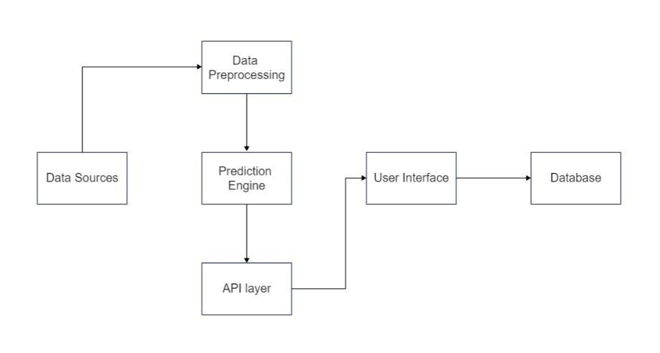

Fig 1. Architecture Diagram

**UML DIAGRAM**

Unified Modeling Language (UML) is a general purpose, development, modeling language in the field of software engineering that aims to provide a standardized way to visualize system design. 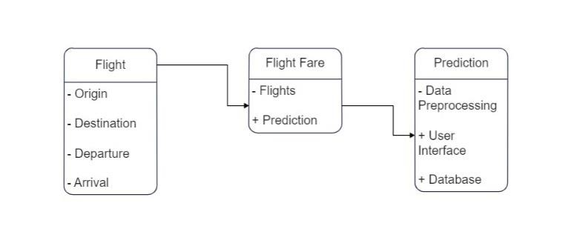

Fig. 2 UML Diagram

**CHAPTER 4**

**SYSTEM SPECIFICATIONS**

A system specification is a structured collection of information that contains system requirements. A system specification describes the functional and non-functional requirements embedded in a system element (system, enabling system, or segment). Requirements for developing system specifications will be derived from high-level system element specifications or general system specifications.

**REQUIREMENT ANALYSIS**

Requirements analysis is the process of analysing, documenting, validating, and managing software in systems engineering and software engineering while taking into account the potentially conflicting requirements of various stakeholders in order to satisfy the needs or requirements of a new or modified product or project. concentrate on the issue that created the circumstance. system specifications.

A system or software project's ability to succeed or fail depends on the results of the requirements analysis. Requirements must be specified in detail enough for system design, be documented, actionable, quantifiable, tested, and tied to clearly defined business needs or capabilities.

**HARDWARE SPECIFICATIONS**

Hardware Requirements The most common requirements defined by any operating system or software are physical computer resources, also known as hardware. The Hardware Requirements List is often accompanied by a Hardware Compatibility List (HCL) in the case of an operating system.

• Processor-Intel

• Ram-4GB

• Hard disk-260GB

• Keyboard

• Mouse

**SOFTWARE SPECIFICATIONS**

Software requirements are concerned with determining the software requirements and conditions that must be installed on the computer in order for the software to function properly. These terms or conditions are usually not included in the software installation package and must be installed separately before the software is installed.

Specifications facilitate the systematic and organized storage of requirements knowledge and effective communication and change management. Use cases, user stories, functional requirements, and visual analysis models are popular choices for defining requirements.

• HTML

• CSS

• Python

**HTML**

HTML stands for Hyper Text Markup Language. A standard markup language for creating web pages. It allows you to create and structure sections, paragraphs, and links using HTML elements (web page structural elements) such as tags and attributes.

HTML has many use cases, namely:

Web development - Developers use HTML code to design how browsers display web page elements such as text, hyperlinks, and media files.

Internet Navigation - Users can easily navigate and link between related pages and websites because HTML is widely used to display hyperlinks.

Web document - HTML allows you to organize and format documents similar to Microsoft Word.

The fact that HTML cannot develop dynamic functionality means that it is not regarded as a programming language. It is now regarded as the accepted web standard. The HTML specification is updated frequently by the World Wide Web Consortium (W3C).

**CSS**

CSS stands for Cascading Style Sheets. It is a language style sheet used to describe the look and feel of a document written in a markup language. It provides additional features for HTML. It is commonly used with HTML to style web pages and user interfaces. It also works with any XML document, including plain XML, SVG, and XUL.

CSS is used in most web applications along with HTML and JavaScript to create user interfaces for web pages and user interfaces for many mobile applications.

**What does CSS do?**

• You can add new views to your old HTML documents.

• With just a few changes to the CSS code, you can change the look of your website.

**Why use CSS?**

There are three major benefits of CSS and are as followed,

1. Solves big problems - Before CSS, specifications such as font, color, background style, element alignment, border, and size had to be repeated on every web page. It's a long process. For example: If you are developing a large website where font and color information is added to each page, this will be a long and expensive process. CSS was designed to solve this problem. It is a W3C recommendation.

2. Saves a lot of time - CSS style definitions are stored in external CSS files, so the entire web page can be changed by changing just one file.

3. Provides more attributes - CSS provides more detailed properties than simple HTML to define the look and feel of a web page.

**PYTHON**

Python, a high-level, interpreted programming language, was first available in 1991. Developed by Guido van Rossum, it emphasizes code simplicity and readability and is loved by both novice and experienced programmers. Python's straightforward syntax simplifies learning and allows developers to write code quickly and efficiently. It is also famous for having pre-built modules and a large standard library that can be used to perform various tasks.

**Features of Python:**

• Python has a straightforward syntax that is simple to learn even for complete beginners.

• Python programming is cross-platform, meaning it can be used with Linux, Mac OS X, and Windows.

• Python supports object-oriented programming, allowing programmers to create reusable, modular programs.

• Python does not require compilation before execution; instead, each line of the code is read and then executed. Testing and debugging code is now simpler and quicker as a result.

• Python includes a sizable standard library that gives programmers access to a variety of modules and functions.

• Python is dynamically typed, which enables variables to hold values of any data type and allows for runtime type changes.

**CHAPTER 5**

**MODULE EXPLANATION**

**5.1 LIST OF MODULES**

Creating an index page 5.1.2 Training the data 5.1.3 Obtaining the pickle file 5.1.4 Building the final application

**5.1.1 CREATING AN INDEX PAGE**

We will be creating an index webpage using HTML and CSS since we’re creating a web application.

**5.1.2 TRAINING THE DATA**

After creating a webpage to run the web application now we will be focusing on training the existing data to train our model. We’ll be using sever machine learning algorithms like Decision Tree Regressor, Random Forest, and Linear Regression algorithm.

**5.1.3 OBTAINING THE PICKLE FILE**

After training the existing data with machine learning algorithms, we should write a set of codes for the trained model to save to a pickle file so that we could easily import and use it in the main application.

**5.1.4 BUILDING THE FINAL APPLICATION**

As we have created an index home page using HTML and CSS and trained the existing data using machine learning algorithms and obtained the trained model as a pickle file, now we must build our main application to import and use the trained data and to run the whole application on the web.

**5.2 USER INTERFACE MODULE**

As we only focused on making the model work proficiently, we didn’t give importance to the user experience even though we used HTML and CSS we just used them to a certain required prototype point. But as a future enhancement, we can work on this project by improving the user interface and by adding several other features.

**5.3 OUTPUT MODULE**

Finally, our proposed system is successfully executed by using machine learning algorithms and our result came out with 99% accuracy.

**CHAPTER 6**

**RESULTS AND DISCUSSION**

Flight Fare Prediction system is something for travelers who are looking to cut costs on their airfare, flight fare prediction systems can be a useful tool. When making a flight reservation, it's crucial to take into account a variety of aspects, including the timing of the booking, the airline's track record for on-time arrivals, and the overall convenience of the flight schedule.

The accuracy of such systems can vary depending on the complexity of the algorithms used, the quality of the data, and the specific factors being considered. Some systems may be more accurate than others, and it's important to keep in mind that predictions are not always guaranteed to be accurate.

**CHAPTER 7**

**CONCLUSION**

In conclusion, flight fare prediction systems can be a useful tool for travelers to estimate the cost of a particular flight, based on various factors such as time of year, destination, and airline. These systems use historical data and algorithms to generate predictions that can help travelers plan their trips and potentially save money on airfare.

However, it's important to keep in mind that the accuracy of these predictions can vary depending on the quality of the data and algorithms used. Therefore, it's always a good idea to compare multiple prediction systems and also consider other factors when booking a flight, such as the reputation of the airline, the convenience of the flight schedule, and the timing of the booking.

Overall, flight fare prediction systems can be a valuable tool in the travel industry, providing travelers with useful information to make informed decisions about their trips.

**DATA TRAINING FILE**

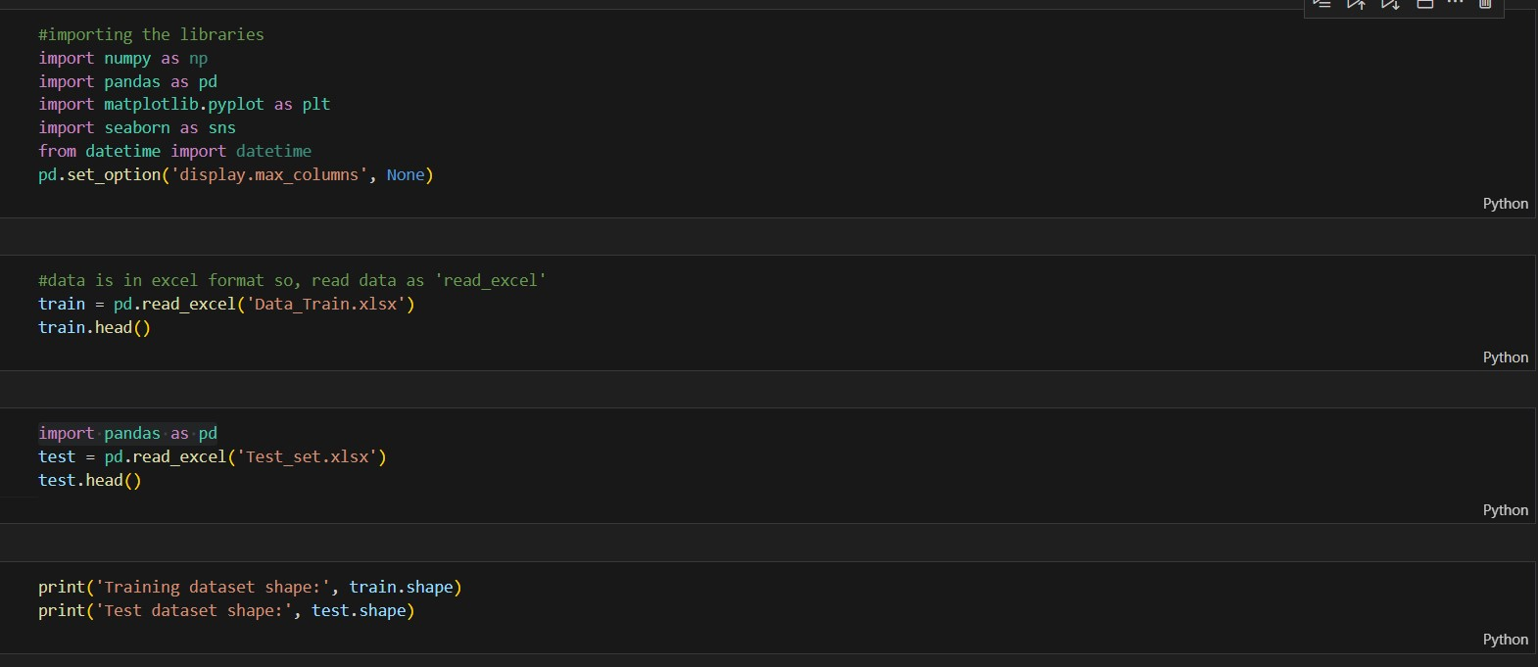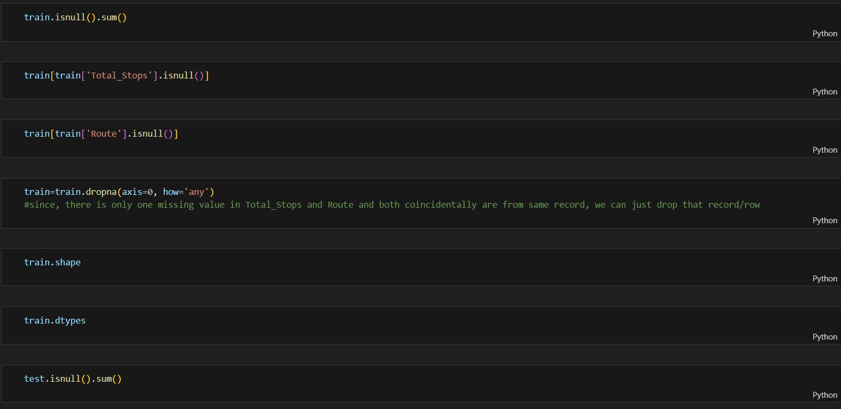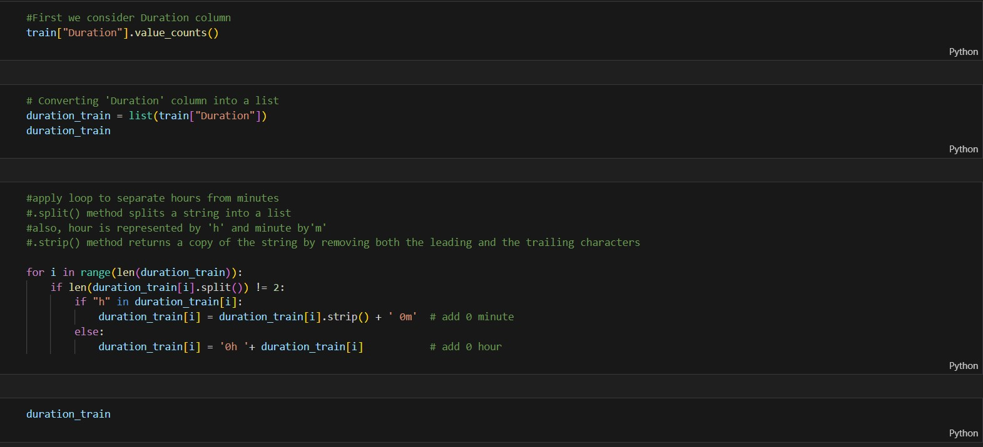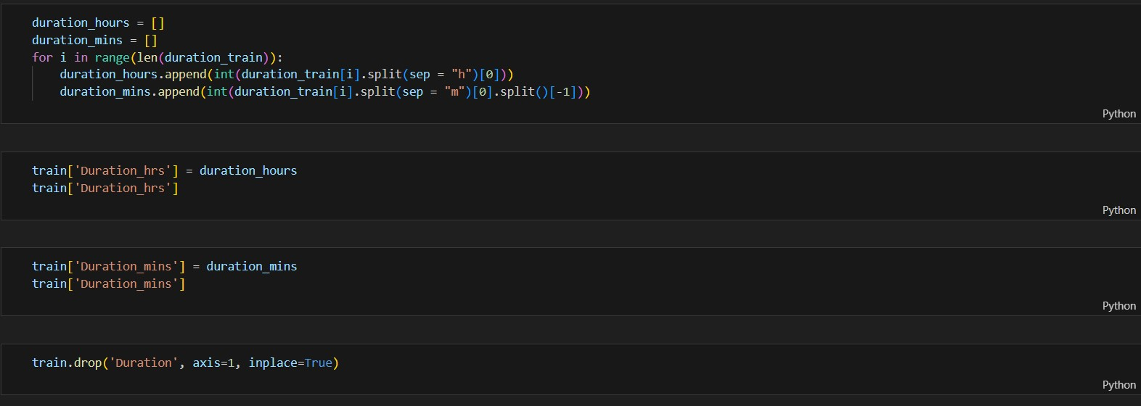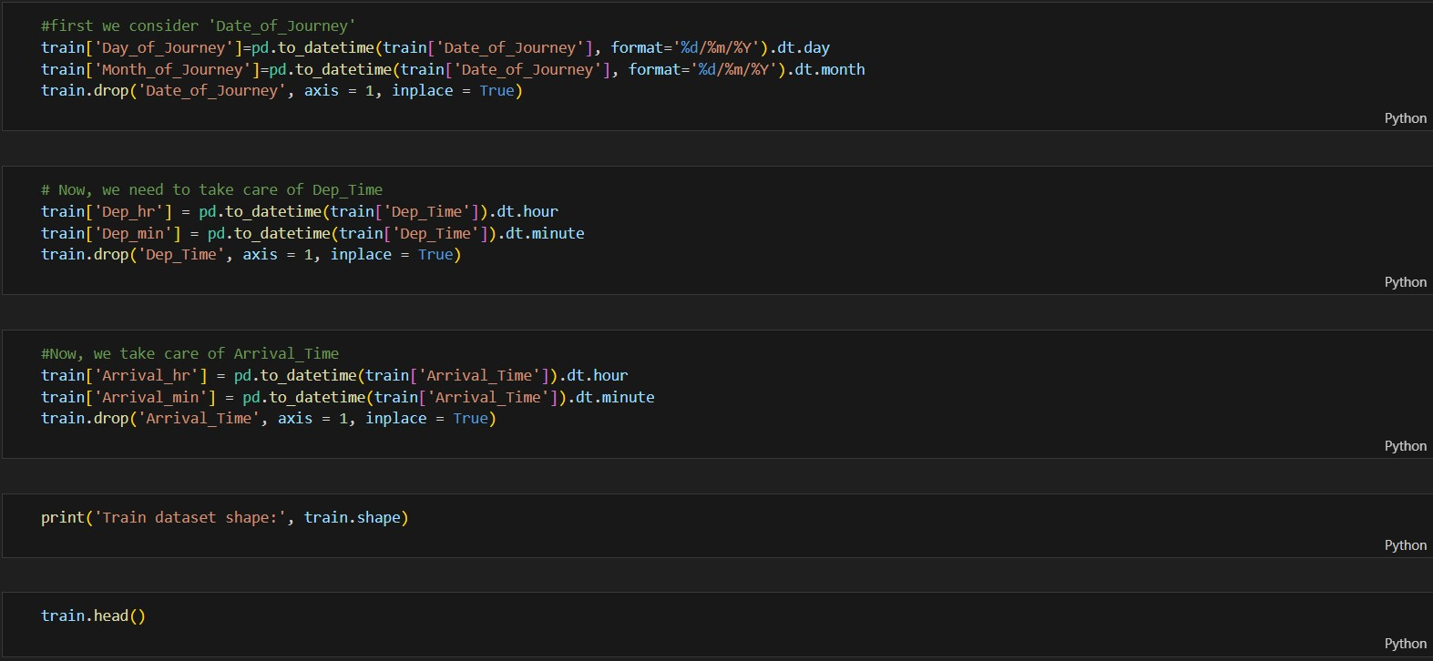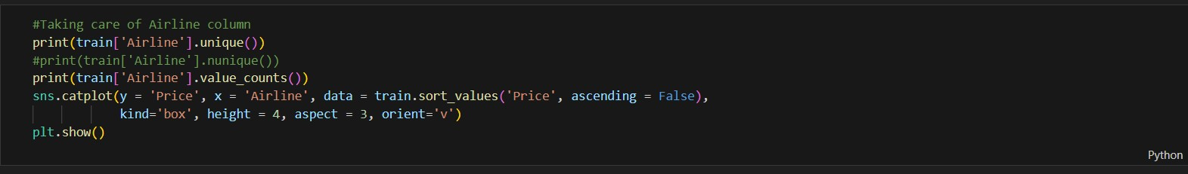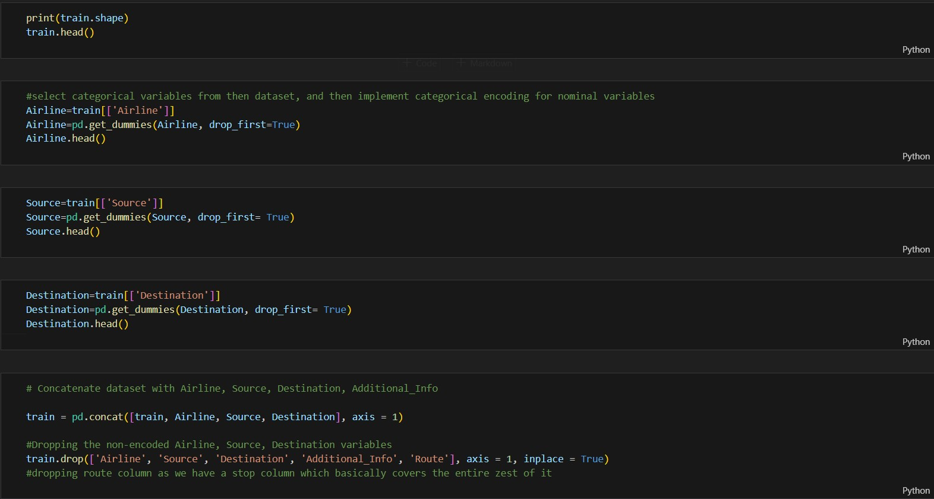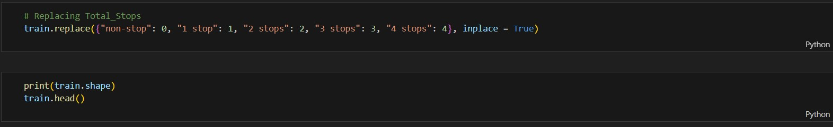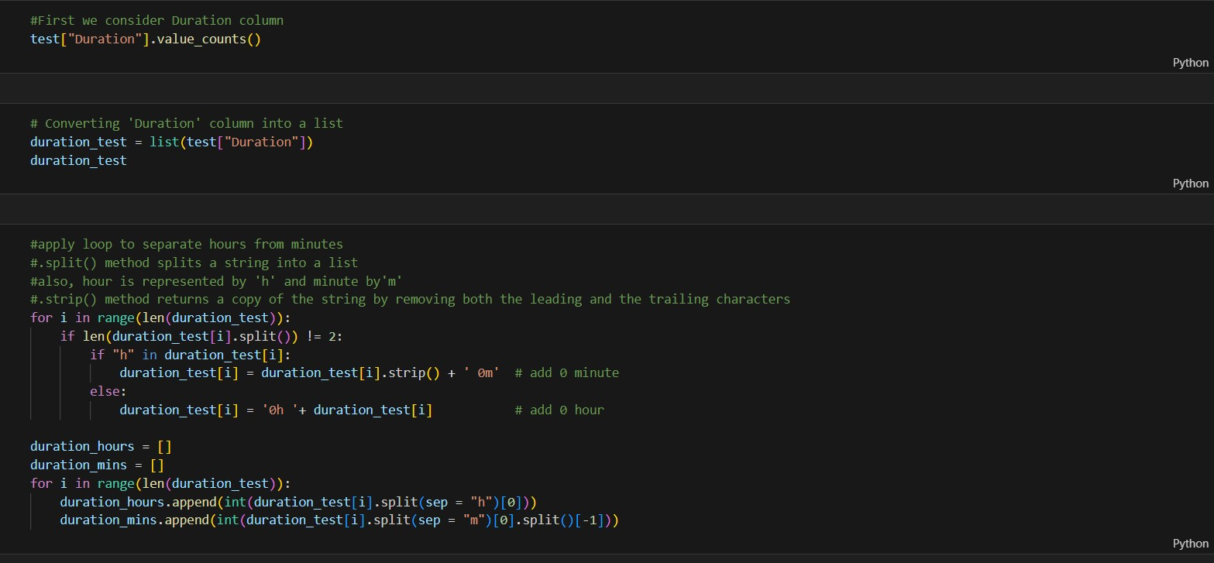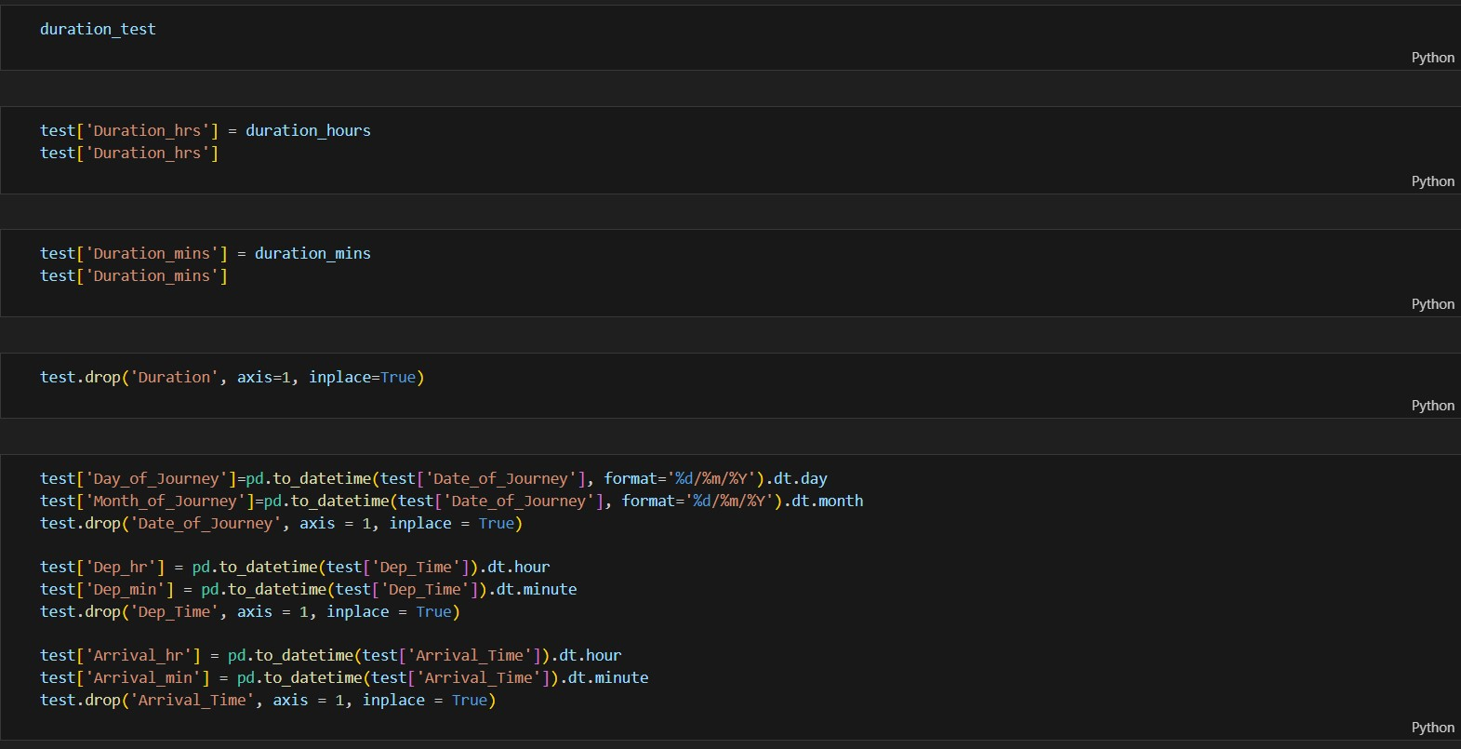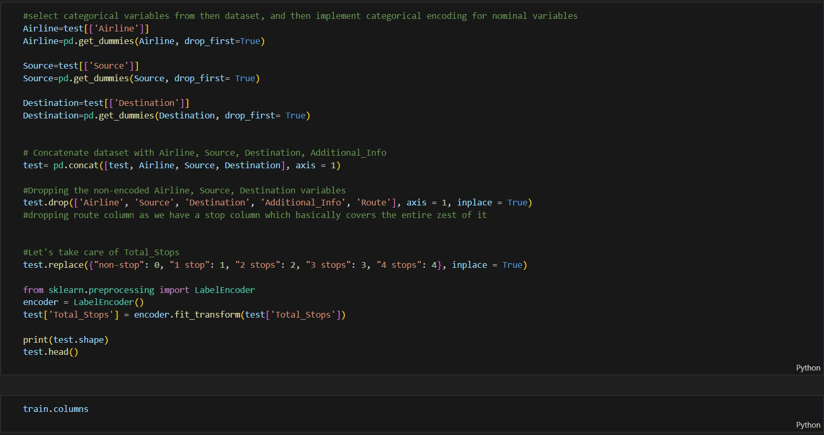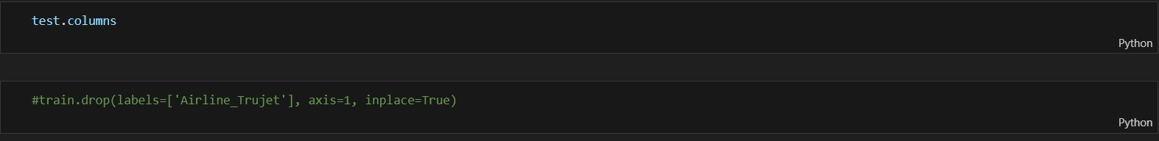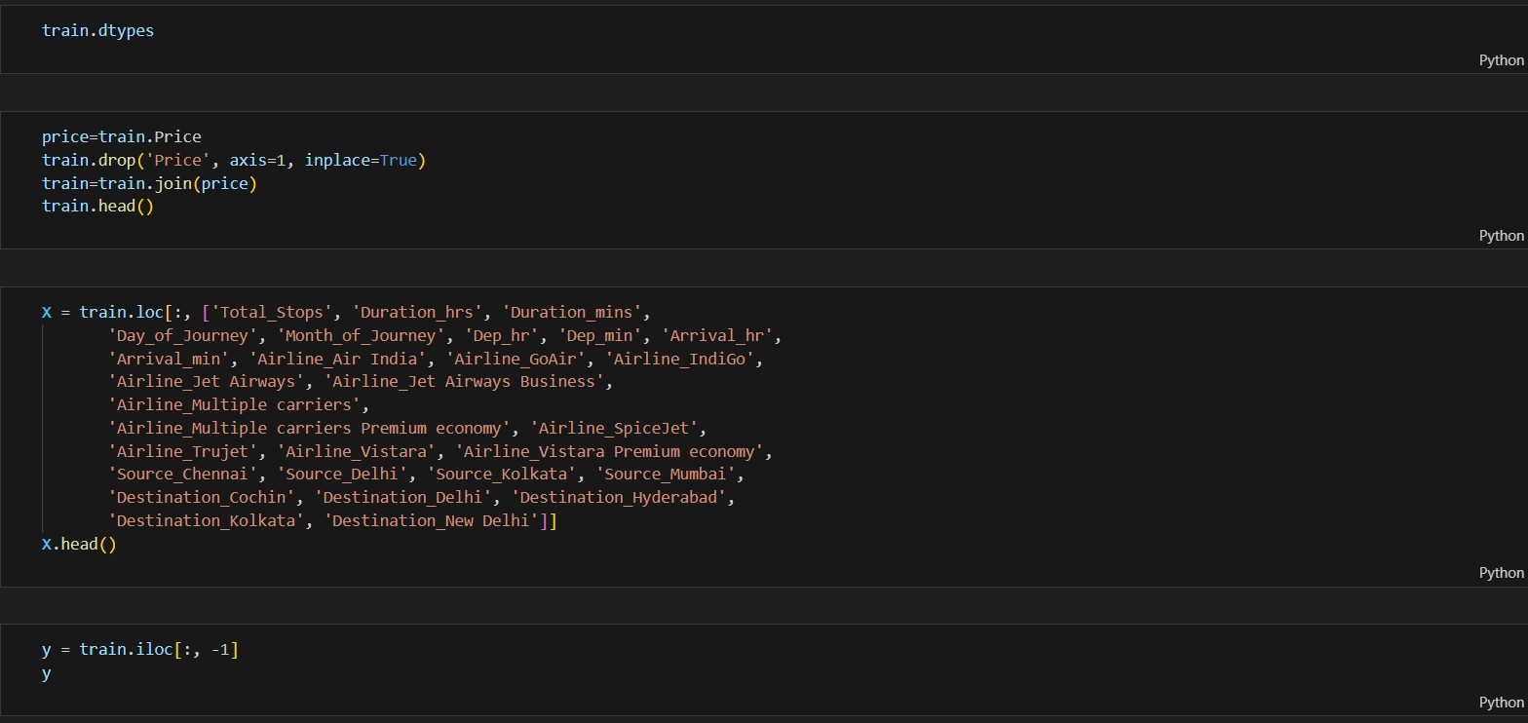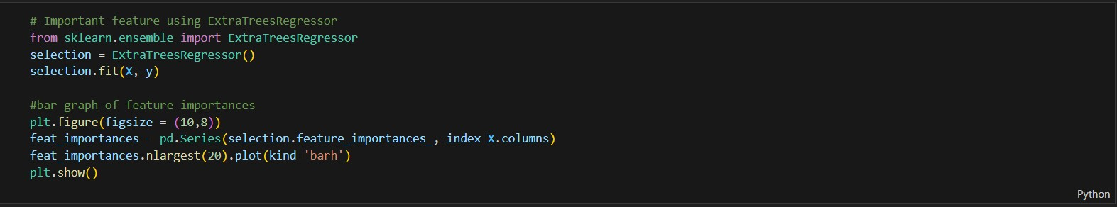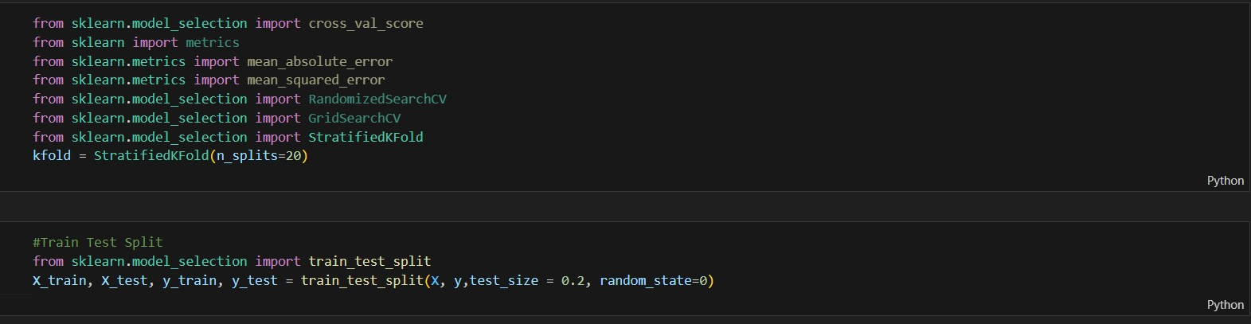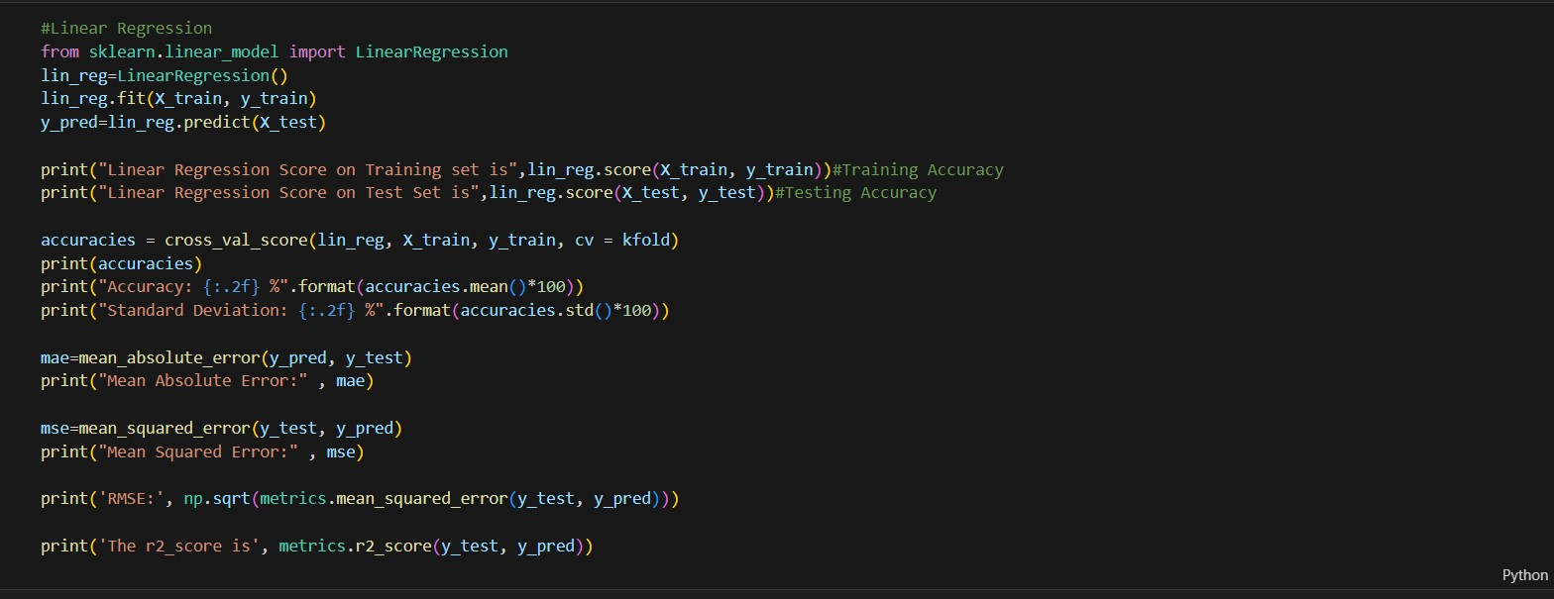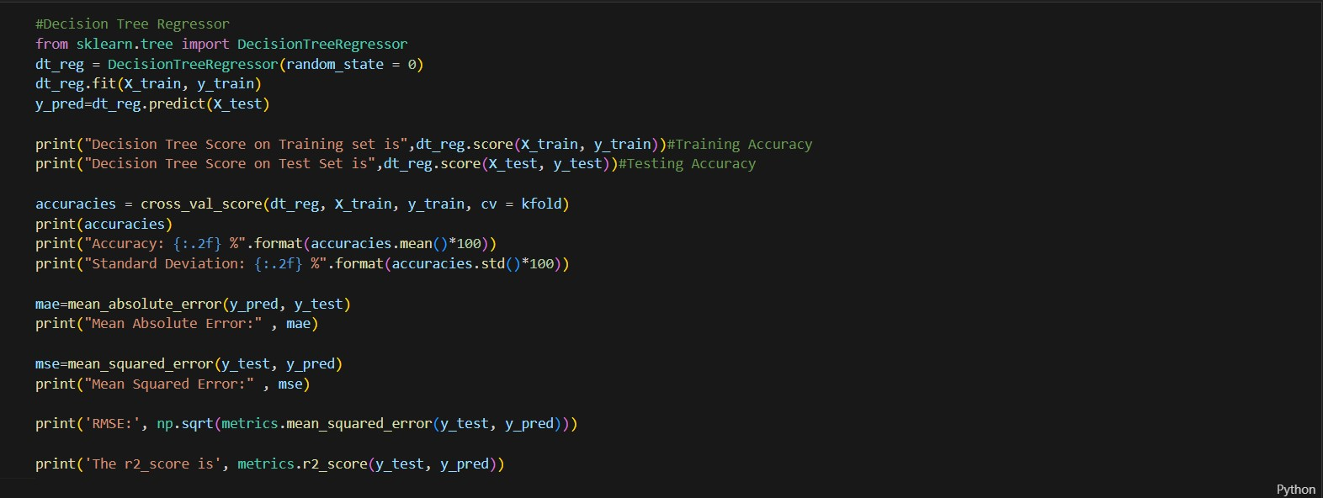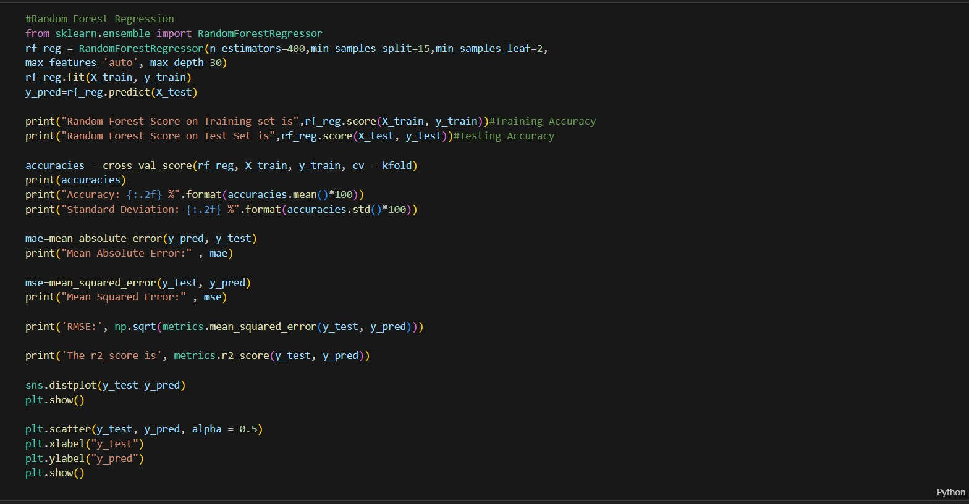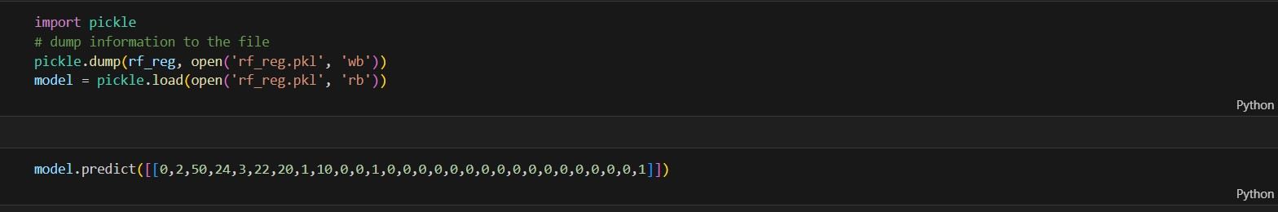

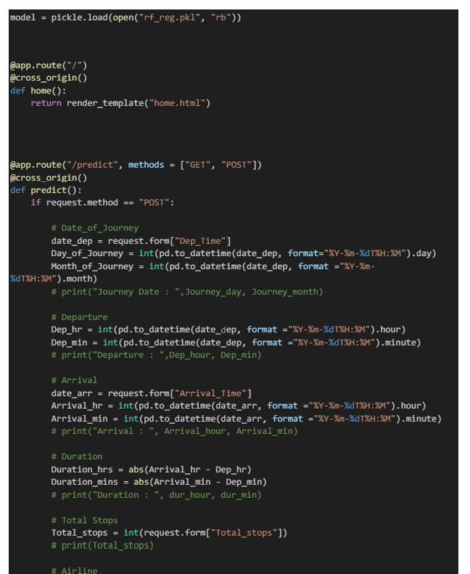

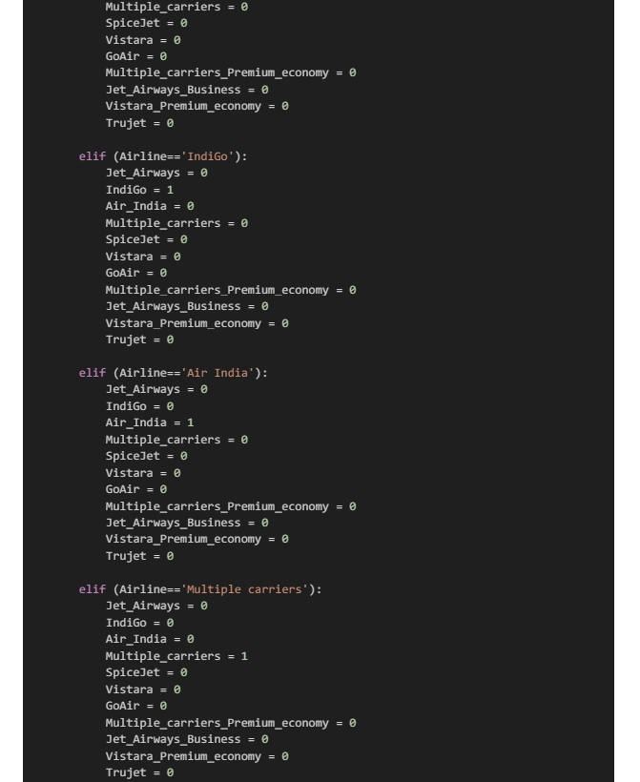

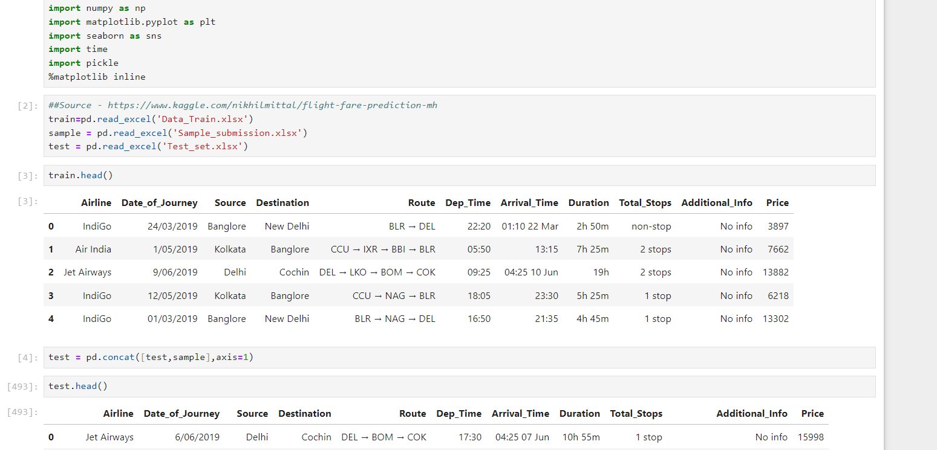

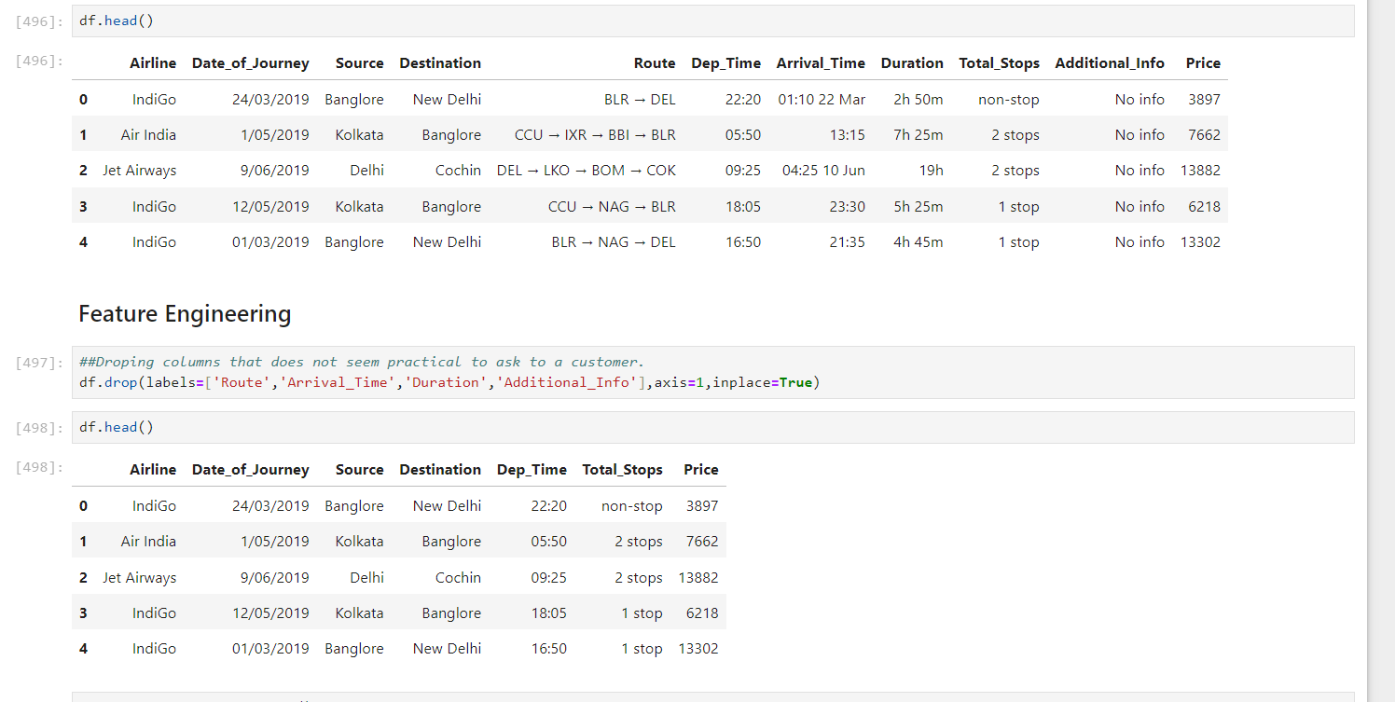

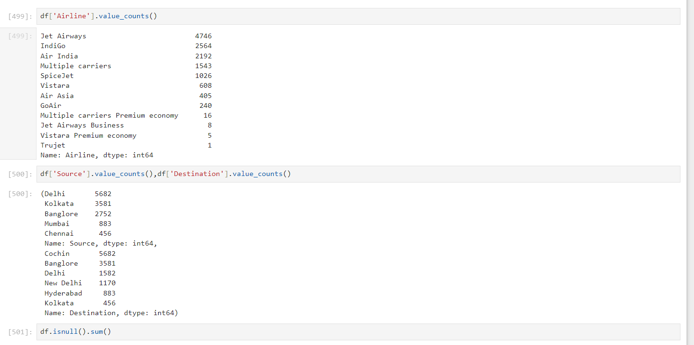

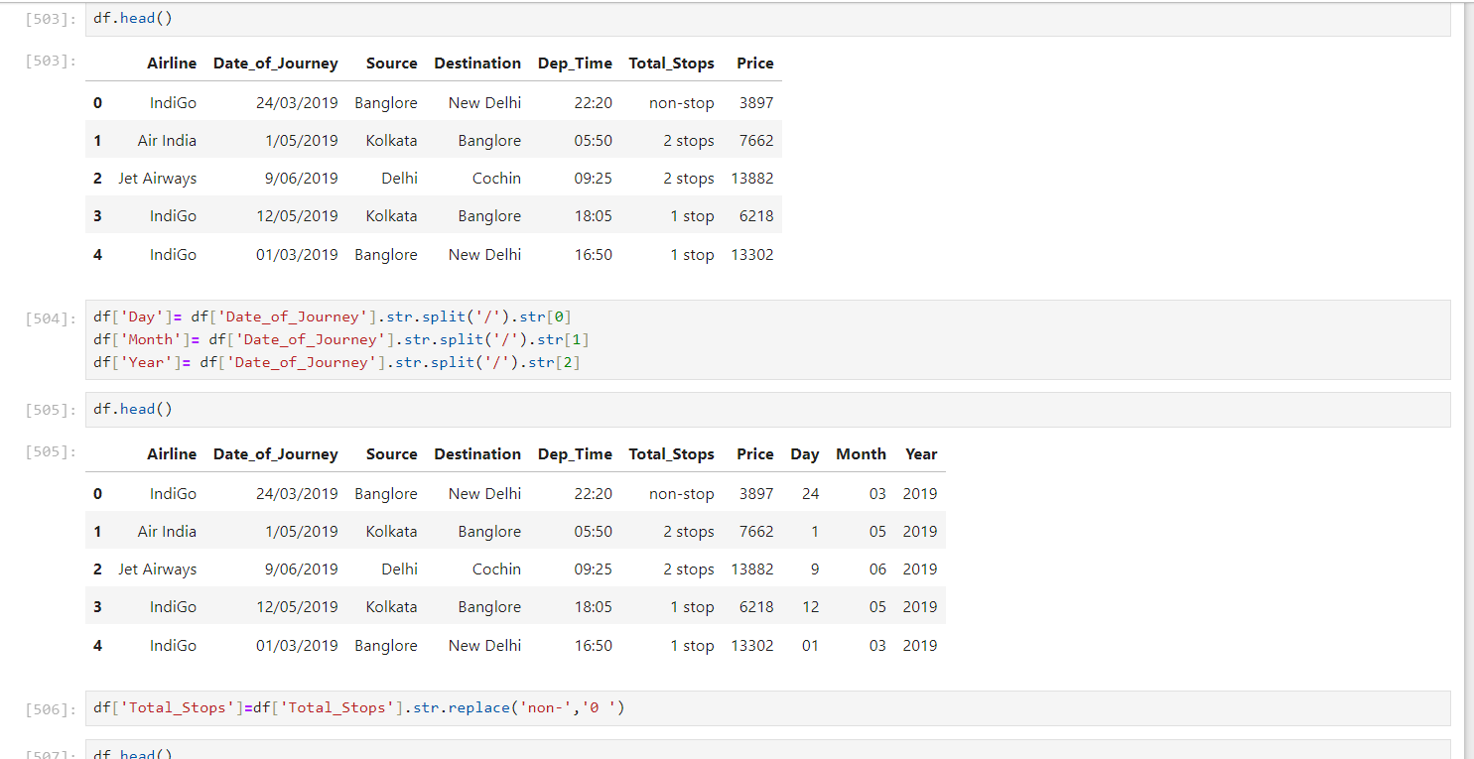

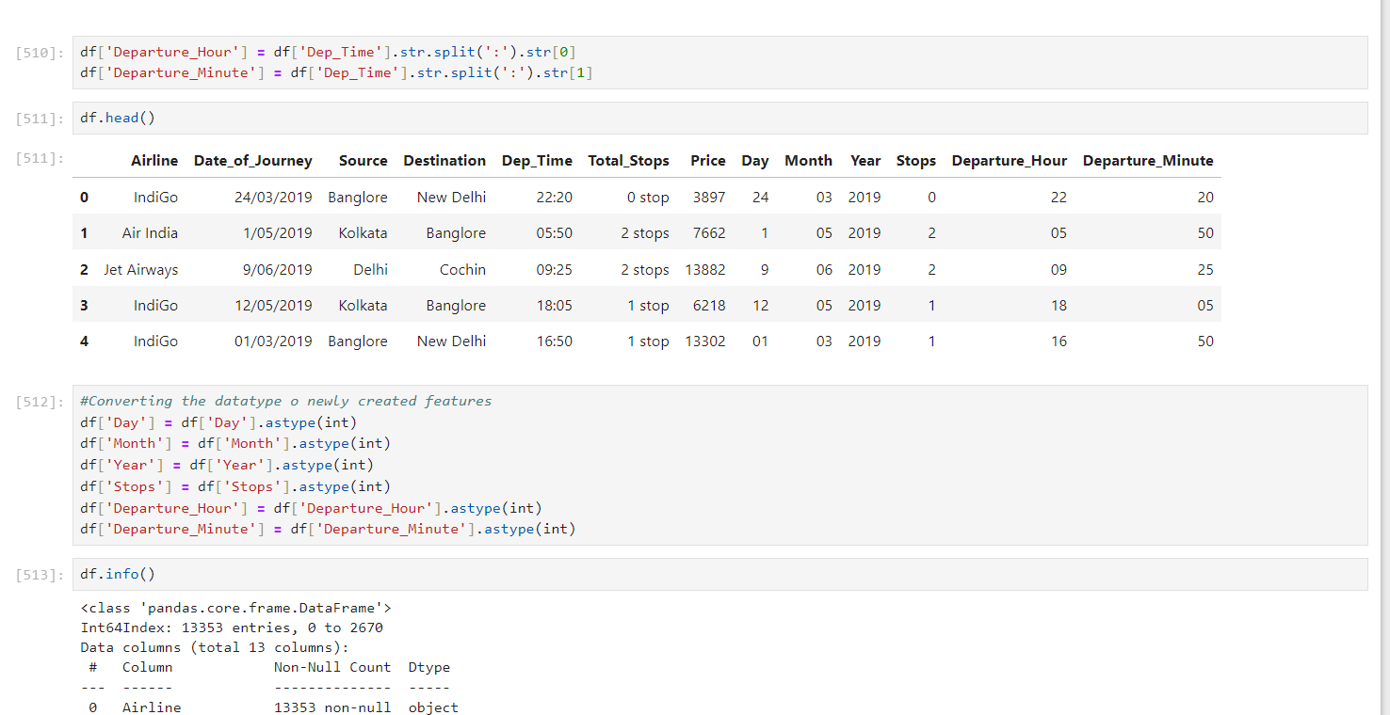

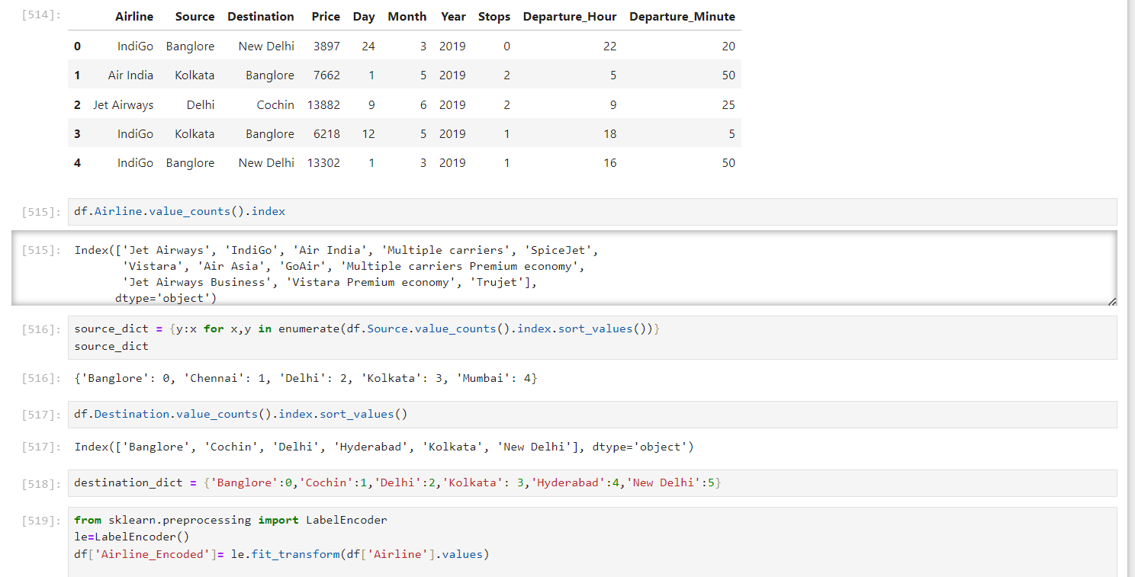

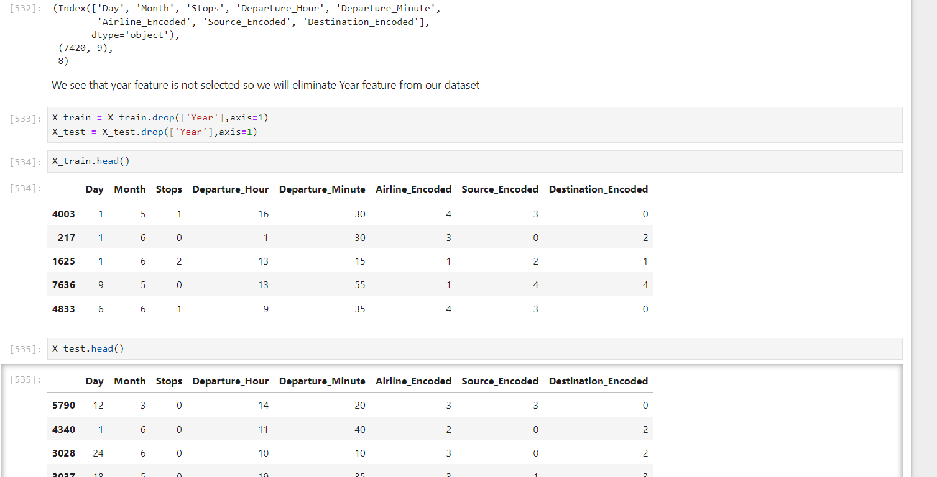

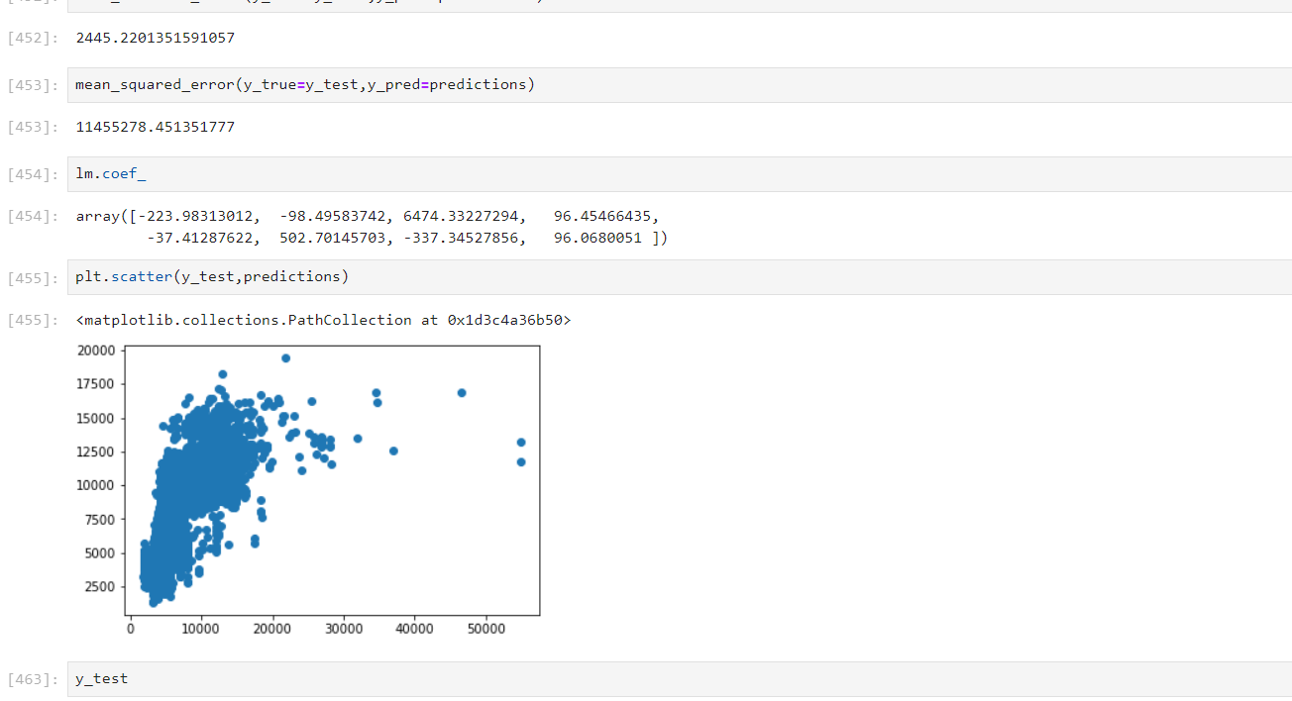

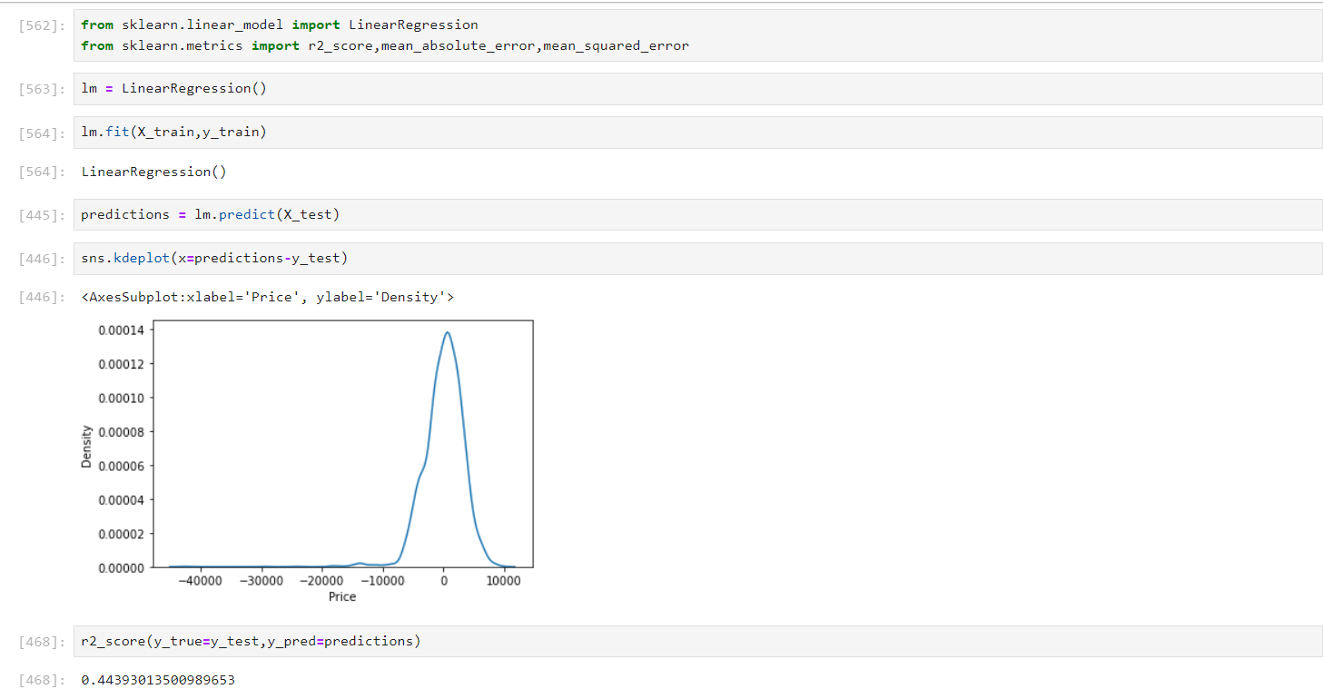

**OUTPUT**

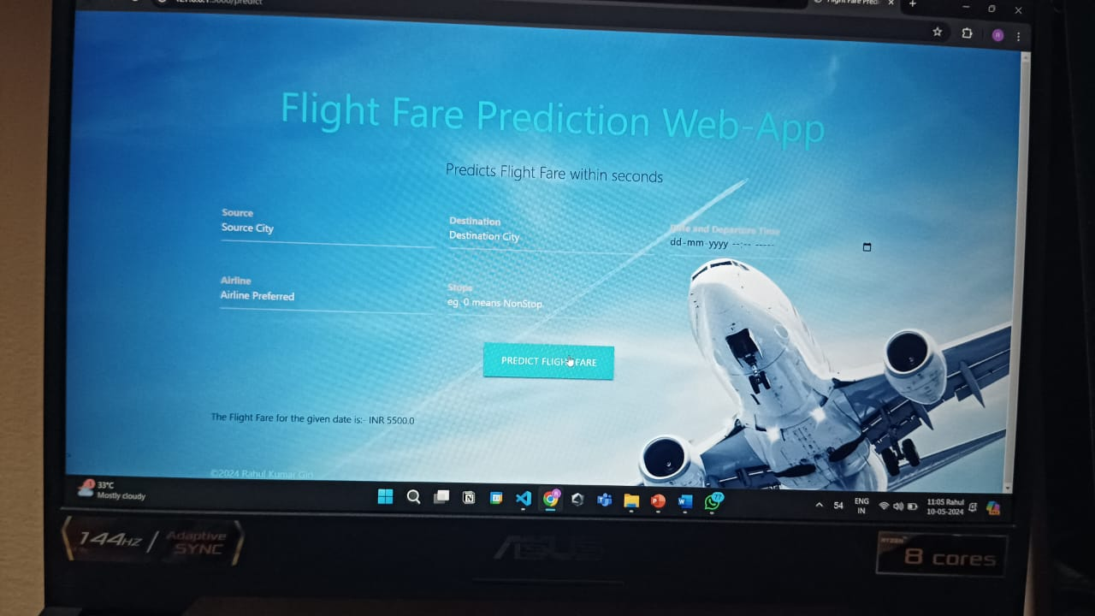

**REFERENCES**

*1. "Predicting Airline Ticket Prices Using Historical Data" Authors: R. B. Patterson and R. M. Patel Published in: International Journal of Computer Applications, Vol. 52, No. 5, 2012.*

*2. Flight Fare Prediction using Historical Data and Machine Learning Techniques" Authors: A. Kumar, et al. Published in: Proceedings of the 3rd International Conference on Computer, Communication, and Signal Processing, 2019.*

*3. "Flight Fare Prediction Using Machine Learning Techniques" Authors: S. G. Sonawane and A. N. Kadam Published in: International Journal of Advanced Research in Computer Science and Software Engineering, Vol. 7, Issue 7, 2017.*

*4. "Airline Fare Prediction Using Machine Learning" Authors: A. L. Rodrigues, et al. Published in: Proceedings of the International Conference on Data Engineering and Communication Technology, 2020.*

*5. "Flight Fare Prediction Using Machine Learning Techniques" Authors: R. N. Sahoo, B. Mishra, and S. P. Dash Published in: Proceedings of the 3rd International Conference on Computational Intelligence in Data Science (ICCIDS), 2019. DOI: 10.1109/ICCIDS.2019.9010314*

*6. "Predicting Airfare using Machine Learning Algorithms" Authors: K. Gupta and S. Agarwal Published in: International Journal of Advanced Research in Computer Science and Software Engineering, Vol. 9, Issue 3,*